Content Gap Analysis Initial Scoping Document
Wikimedia Community User Group Uganda (WCUGU)

1. Introduction
The Wikimedia Community User Group Uganda (WCUGU) seeks to strengthen Uganda’s representation across Wikimedia projects by addressing knowledge gaps that exist between English and Luganda Wikipedia, and across Wikimedia Commons. Despite recent progress (including significant increases in editor participation, article creation, and multimedia uploads), substantial disparities remain in terms of coverage, depth, and representation.
This document provides the initial scoping for a Content Gap Analysis, which will:
- Assess current coverage of Uganda-related topics.
- Identify missing, underdeveloped, or biased areas of content.
- Establish priorities for future editing, translation, and community engagement initiatives.

2. Objectives
The Content Gap Analysis will:
- Map Content Coverage: Generate a complete dataset of articles and categories related to Uganda.
- Identify Gaps: Compare existing coverage in English and Luganda Wikipedia to highlight missing and underdeveloped content.
- Prioritise High-Impact Areas: Use viewership, quality assessments, and cultural relevance to identify priority topics.
- Support Strategic Action: Provide actionable insights to inform WCUGU’s campaigns, edit-a-thons, and partnerships with educational and cultural institutions.

3. Scope of Work
The analysis will cover three dimensions of Wikimedia content:
A. Wikipedia (English & Luganda)
- Coverage: Categories and subcategories directly related to Uganda.
- Quality: Classification of articles into Stub, Start, C, B classes.
- Comparisons: Gaps between English and Luganda versions, with a focus on high-view topics not translated into Luganda.
- Biases: Assessment of underrepresented groups and themes (e.g., women, rural communities, creative industries, scientific research).
B. Wikimedia Commons
- Quantity: Total files and categories relating to Uganda.
- Distribution: Balance across themes (culture, people, geography, environment).
- Campaign Integration: Evaluate how campaigns like Wiki Loves Earth and Wiki Loves Monuments contribute to Commons representation.
C. Engagement & Usage
- Viewership: Ranking of most-read Uganda-related articles (English and Luganda).
- Editing Trends: Number of active editors, new contributors, and translation activity.
- Impact Analysis: Match user interest (views) with content gaps (missing or underdeveloped articles).

4. Methodology
Data Extraction
- Extract categories and articles tagged under "Uganda" on English and Luganda Wikipedia.
Used Petscan to extract all the articles mentioning Uganda or are in the Uganda category, but have no links to lgwiki, have not been translated or have broken Wikidata items to lgwiki
Used Wikimedia API to recursively iterate the category Uganda and its children subcategories in both Wikimedia and Commons to identify present work already published.
- Gather page views data from Wikimedia tools.
Pageviews - Fetches the view of pages, categories over time
Wikistats - Checks total views for wiki Uganda and the different activities in that wiki (Massviews and Topviews alike, but for comprehensive data)
- Retrieve Commons categories and file counts.
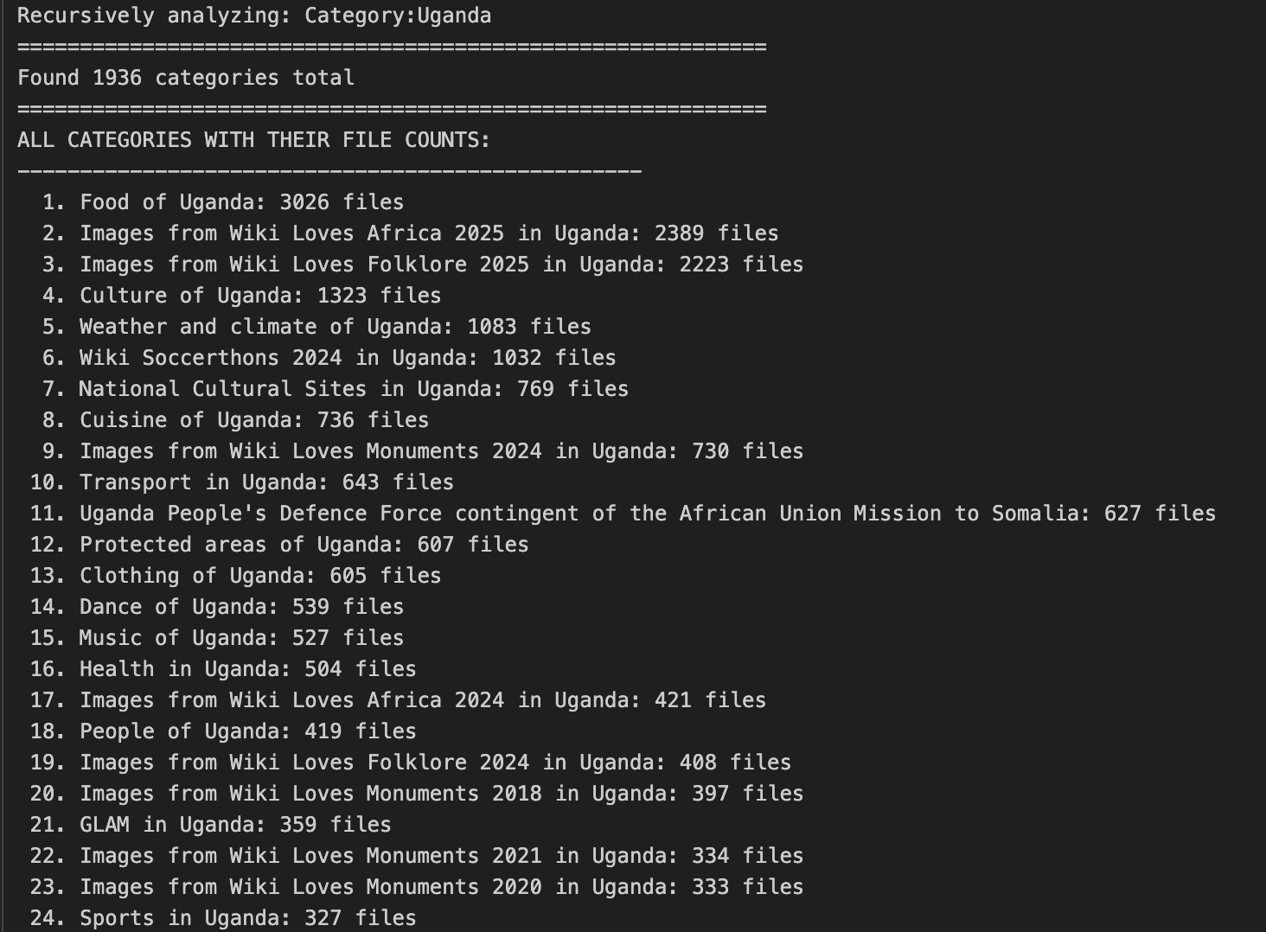
Ranking and Prioritisation
- Rank articles and categories by viewership.
- Flag articles with high readership but low quality or incomplete coverage.
Quality Assessment
- Assess article length, references, and classification (Stub, Start, C, B, etc.).
- Categorise articles requiring expansion or translation.
Stub Categorisation
- Map stubs by subcategory (e.g., people, geography, sports, buildings).
- Quantify the number of stubs and estimate expansion effort.
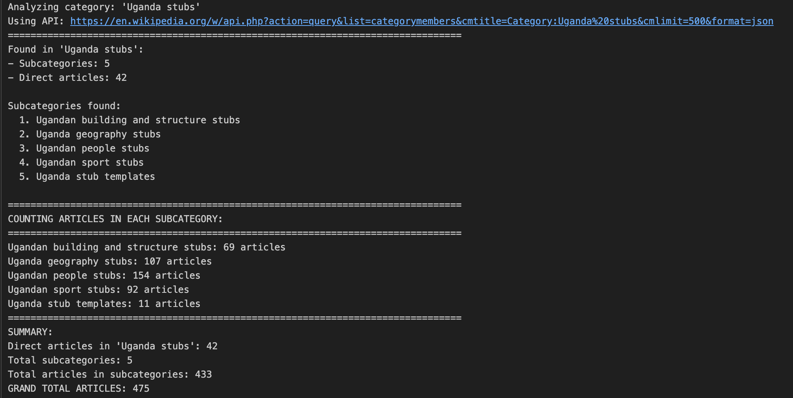
Commons Analysis
- Count Uganda-related files across subcategories.
- Identify underrepresented multimedia areas.
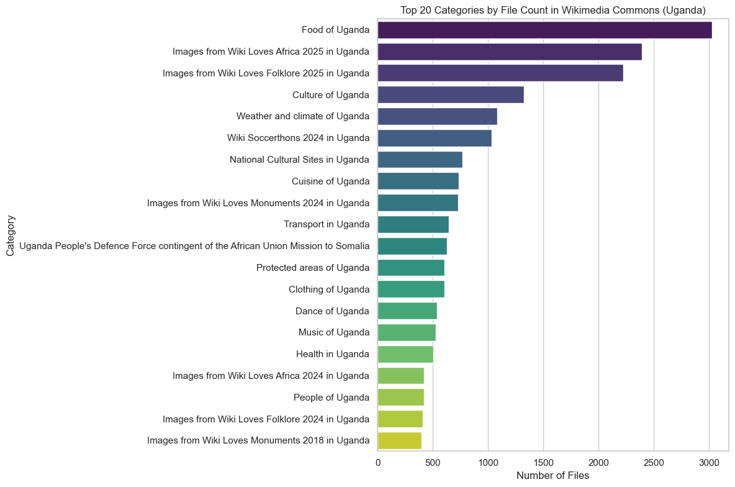
Representation Bias Review
- Analyse thematic balance (history vs economy, men vs women).
- Identify missing perspectives from marginalised communities.

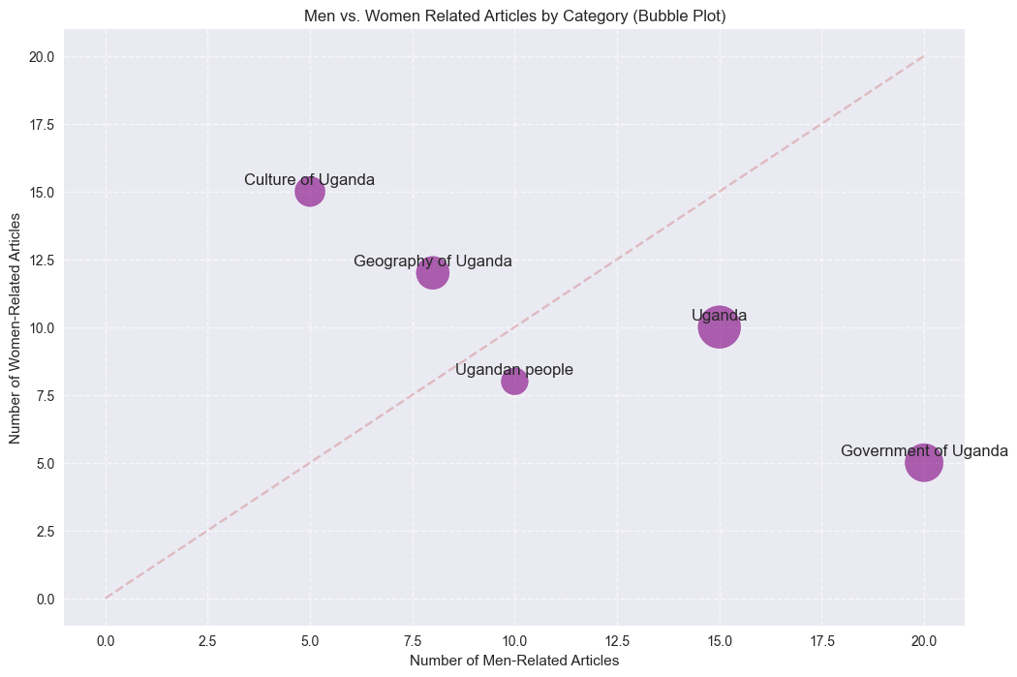
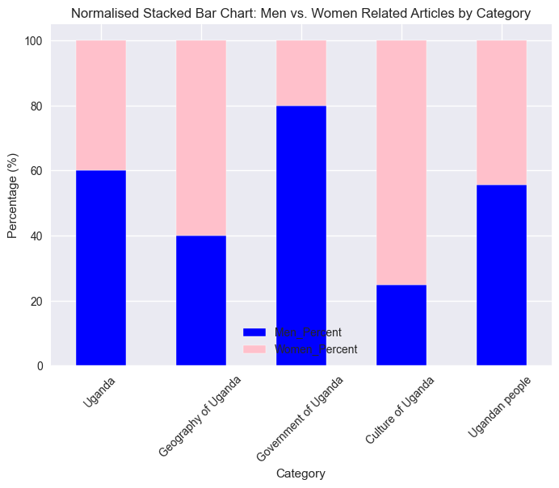

5. Key Questions
- What articles exist about Uganda across English and Luganda Wikipedia?
uganda_comprehensive_coverage.xlsx
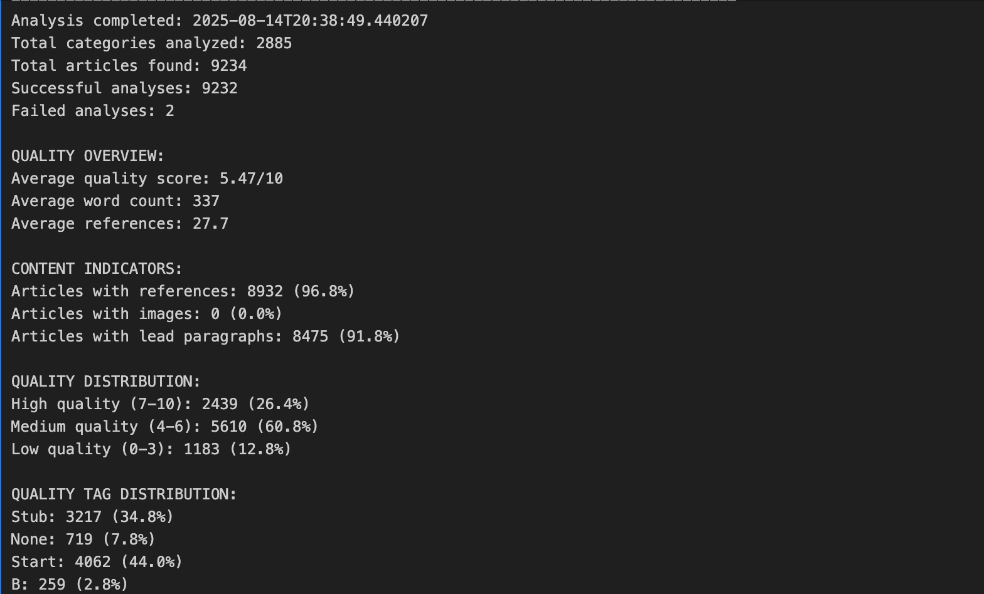

- Which Uganda-related articles in English have not been translated into Luganda?
GAP -Overview

- How many articles are stubs or incomplete, and in what categories?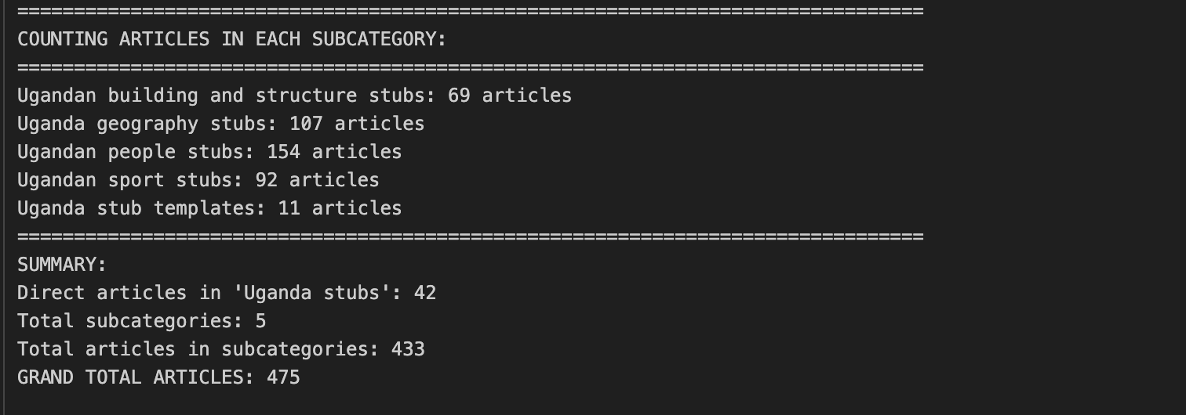
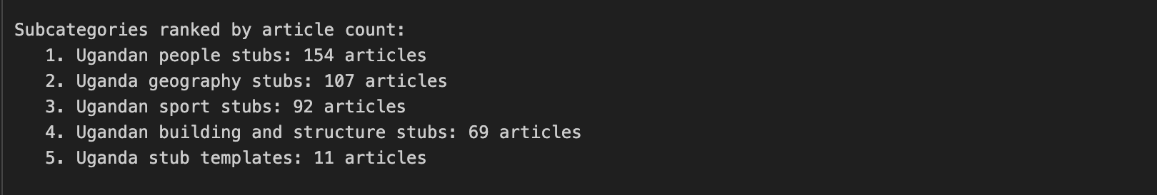

- Which categories/topics have the highest readership but weakest content coverage?
Top category in readership: History of Uganda
Top topic: 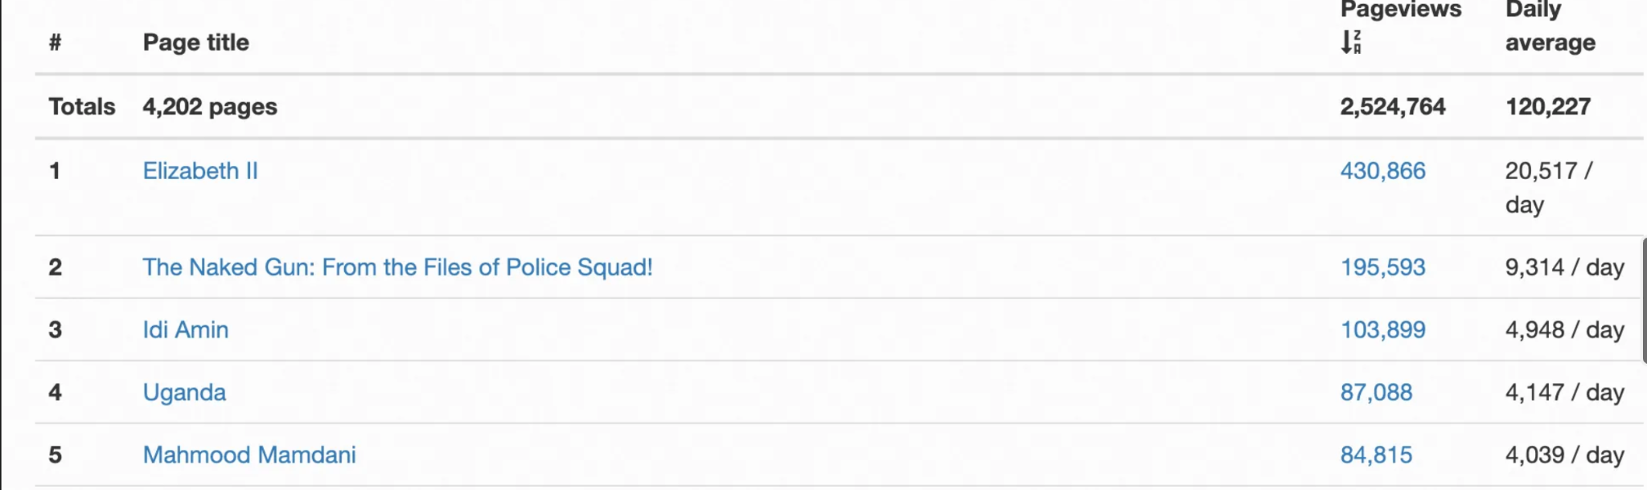
Quality distribution in this category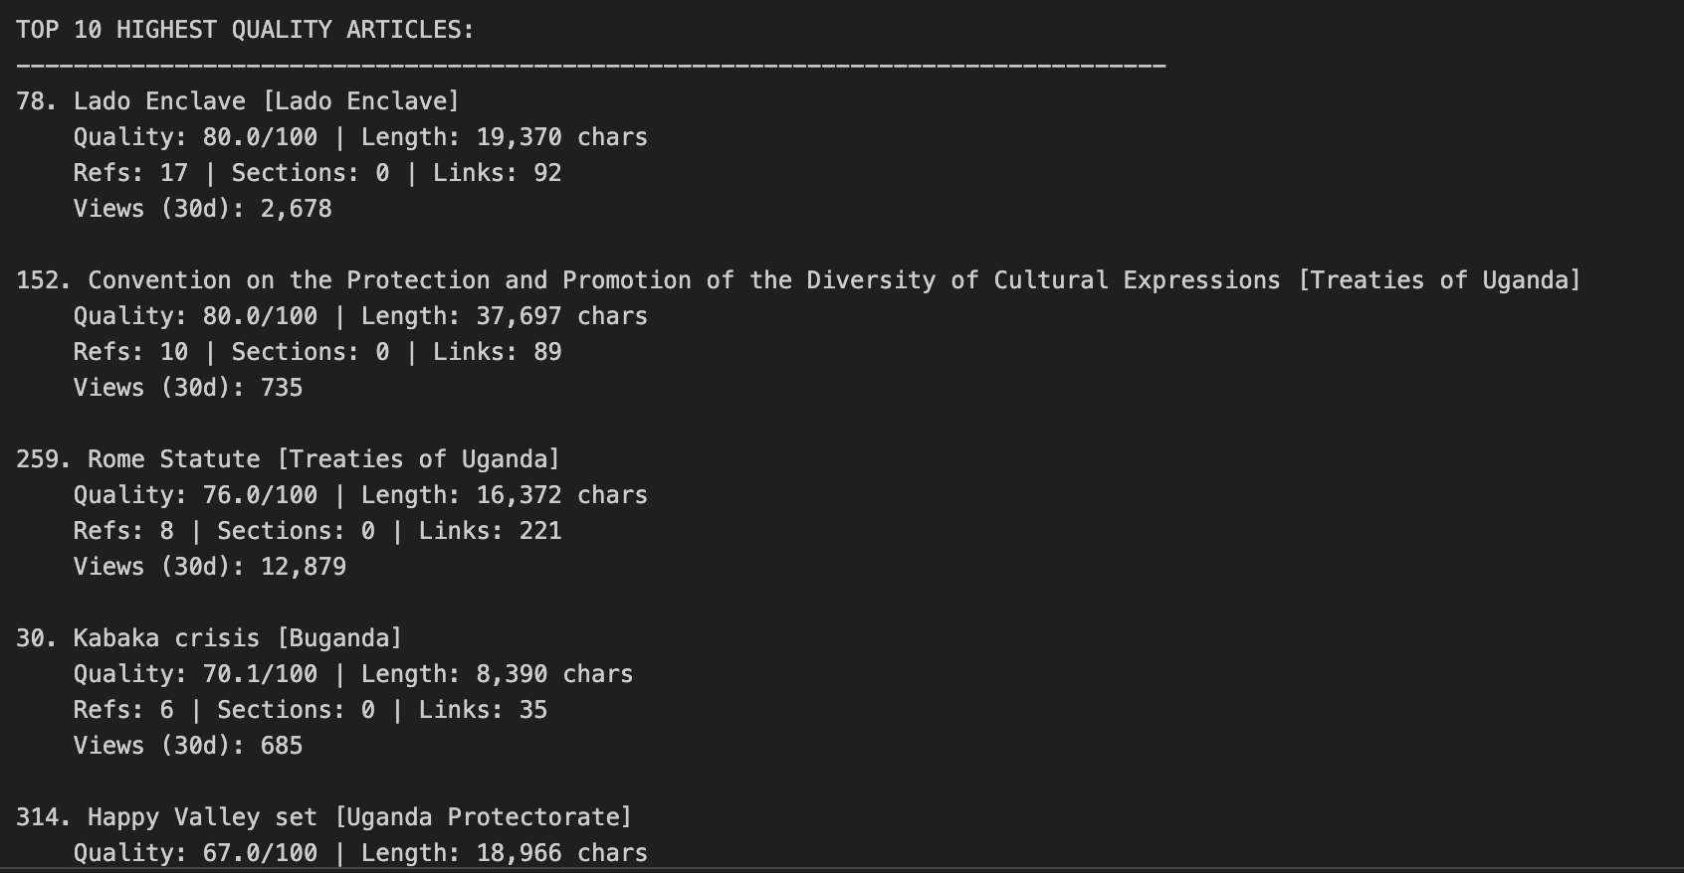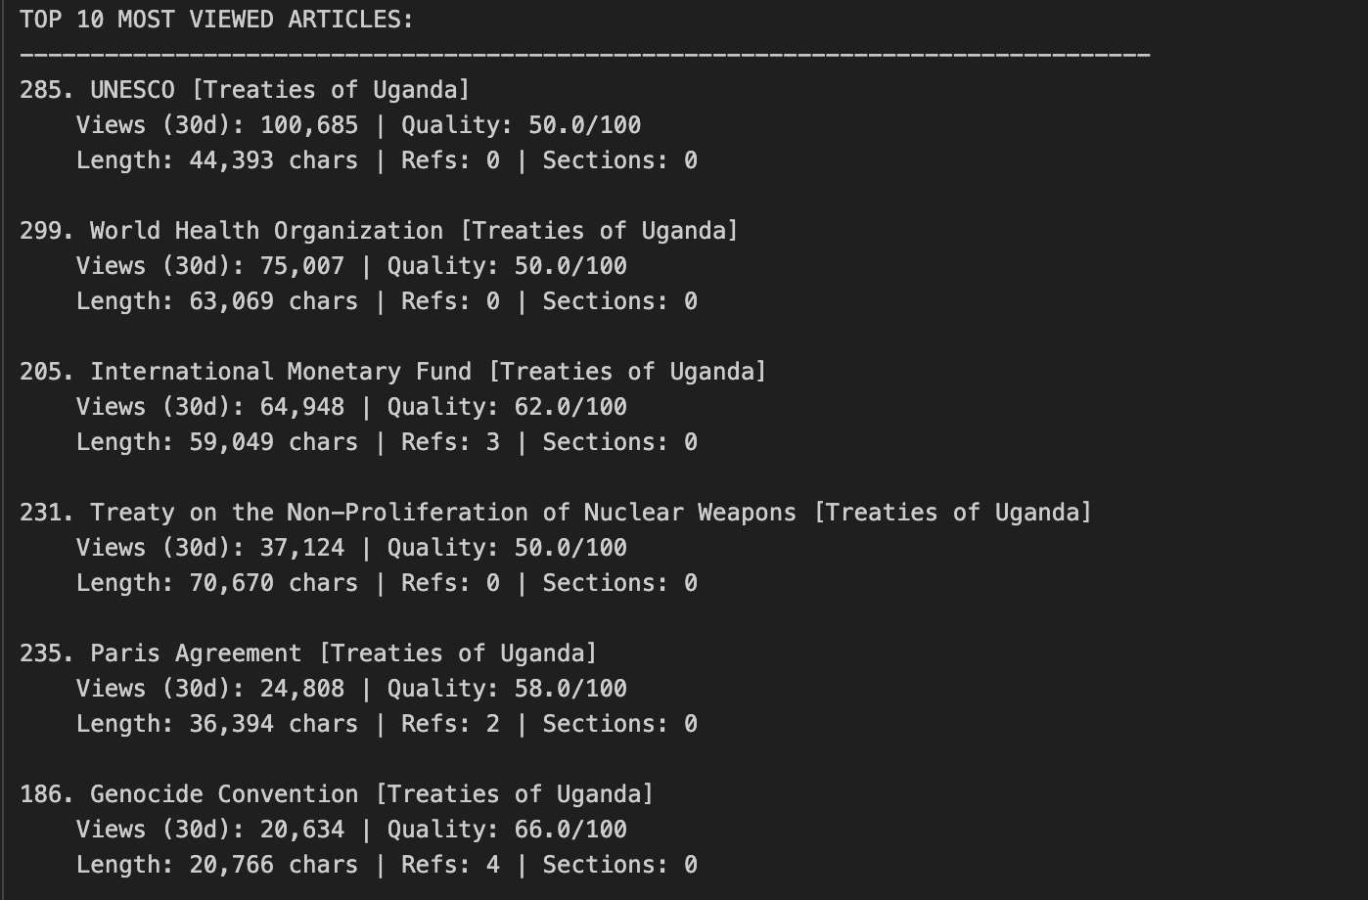
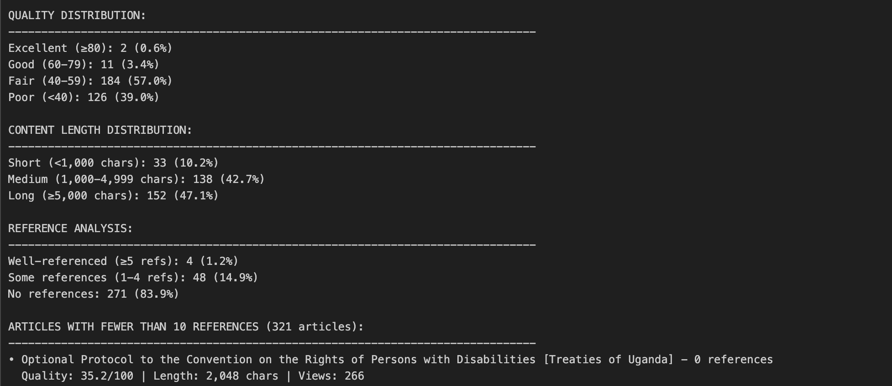

- Are there systemic biases (e.g., gender, geography, thematic focus) in current content?
Editor Demographic bias: we have active 28 editors according to massviews (might need a manual headcount to update the accurate data). This might affect the publications available being dominantly about men or a certain topic.

Implicit Bias: We see a number of incomplete and missing topics on category Uganda and lgwiki. For example, basic topics like ‘Menstruation Health’ are missing on lgwiki and have not been translated to Luganda from enwiki.

Source Availability Bias: inadequate reliable secondary sources in most of the articles across category Uganda and this might reflect on the number of incomplete articles/ stubs/ templates count

- How well is Uganda represented on Wikimedia Commons?
Total categories found: 1936 (This includes top namespace and all their children recursively)
Total files across all categories: 43087
GOOD representation overall.
Majority of files (≥ 96% are photos)
- How do editing and translation trends compare to viewership demand?
Total edits for July: 828
Total media requests for July: (Wikistats only gives for all wikis and not for Uganda specifically)
Articles not yet translated: GAP -Overview

6. Current Baseline (as of August 2025)
Wikipedia (English Uganda Category)
Metric | Value
Categories Analysed | 31/35 complete
Articles | 25, 278 ( Across 2, 888 categories +subcat)
With ≥ 1 Citation | 96.8%
Stub Class Articles | 34.8 %
Unclassified | -
Start Class | 44.0 %
C class | 10.6 %
B class | 2.8%

Stub Breakdown (475 articles in “Uganda stubs”)
Stub Type | Count
People | 154
Geography | 107
Sports | 92
Buildings/ Structures | 69
Other/ templates | 11

Wikimedia Commons
Metric | Value
Files | 43, 087
Categories (+ children) | 1, 936
Engagement & Usage
Metric | Count
Page Views | 3M total as of Aug 2025
Top views | History of Uganda (All time), Economy of Uganda (July 2025)
Community | 20 active editors (July 2025)

7. Challenges
- Data Retrieval: API requires multiple calls for nested categories, leading to incomplete captures.
- Categorisation Variance: Articles/files often miscategorised, requiring manual checks.
- Computational Load: Processing large datasets takes time.
- Campaign Representation: Automated queries miss some campaign outputs.
- Community Capacity: Limited pool of active editors in Luganda Wikipedia.

8. Expected Outputs
- Gap Mapping Report – List of missing/underdeveloped content.
- Priority Matrix – Ranking by readership, cultural value, and completeness.
- Commons Audit Report – Multimedia coverage assessment.
- Recommendations:
  - Content creation drives (edit-a-thons, contests).
  - Translation of high-traffic English articles to Luganda.
  - Peer review and mentorship for quality control.
  - Strengthen Commons campaigns.

9. Next Steps
- Stakeholder Validation – Present scope for feedback.
- Expanded Data Extraction – Run scans for missing categories.
- Comparative Analysis – Deep dive into English/Luganda disparities.
- Visualisations – Coverage maps, stub prevalence, readership vs quality.
- Draft Report – Compile findings for action.

10. Conclusion
Wikimedia already hosts thousands of articles and tens of thousands of media files about Uganda, but gaps remain in coverage, quality, and representation. This analysis will provide WCUGU with a roadmap to strategically address these gaps, improve knowledge equity, and build a richer, more inclusive representation of Uganda on Wikimedia platforms.

11. Appendices
Tools used:
Petscan for extracting Luganda content
Wikimedia API calls for all other metrics
Python programming language for interpreting the API messages
Resulting Jupiter notebook with all the code for documentation (Available)

